**JENKINS FOR BANKING SYSTEMS – March 17 2019**

1. **Main folder consisting of various banking Jenkins job**

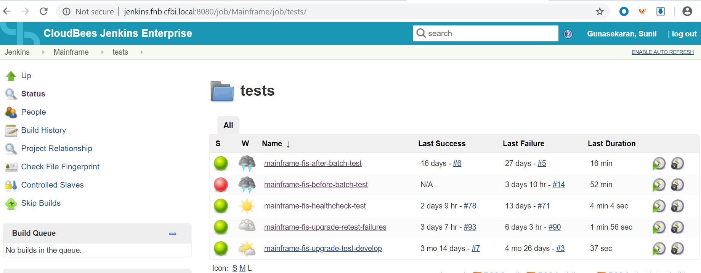

1. **PIPELINE DASHBOARD**

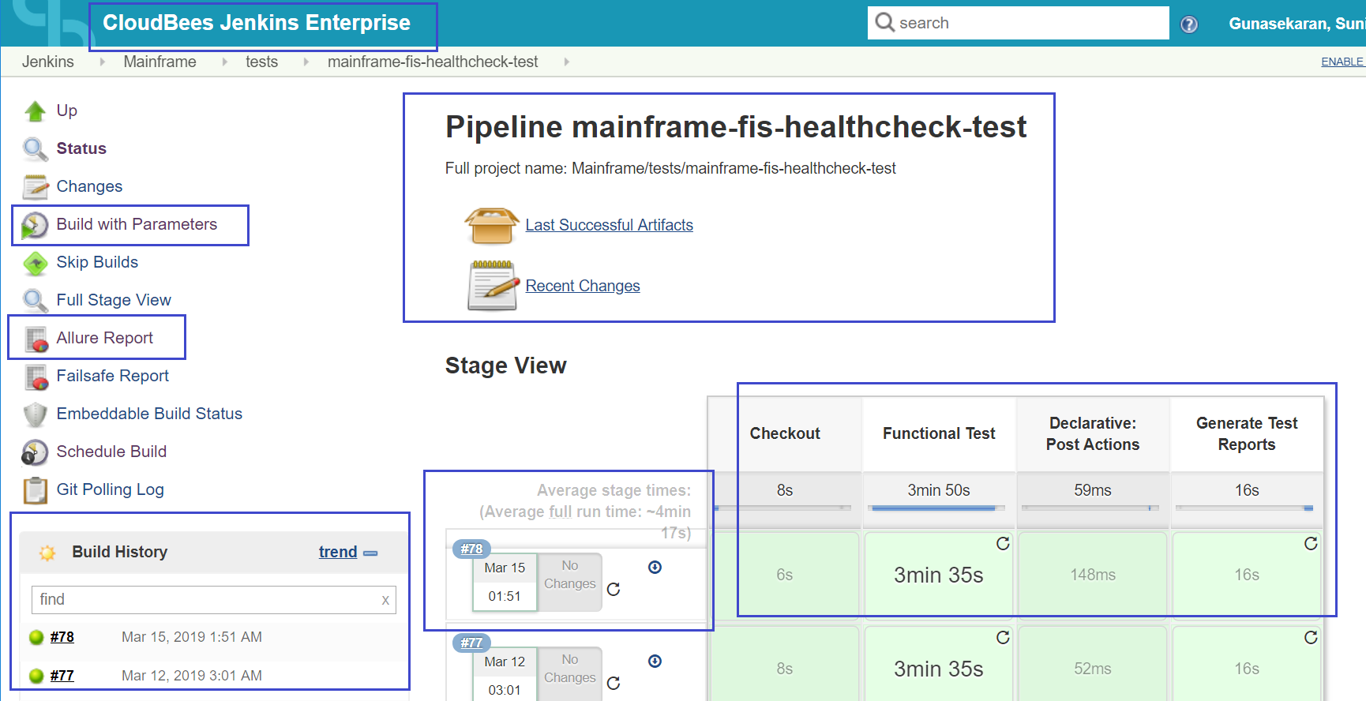

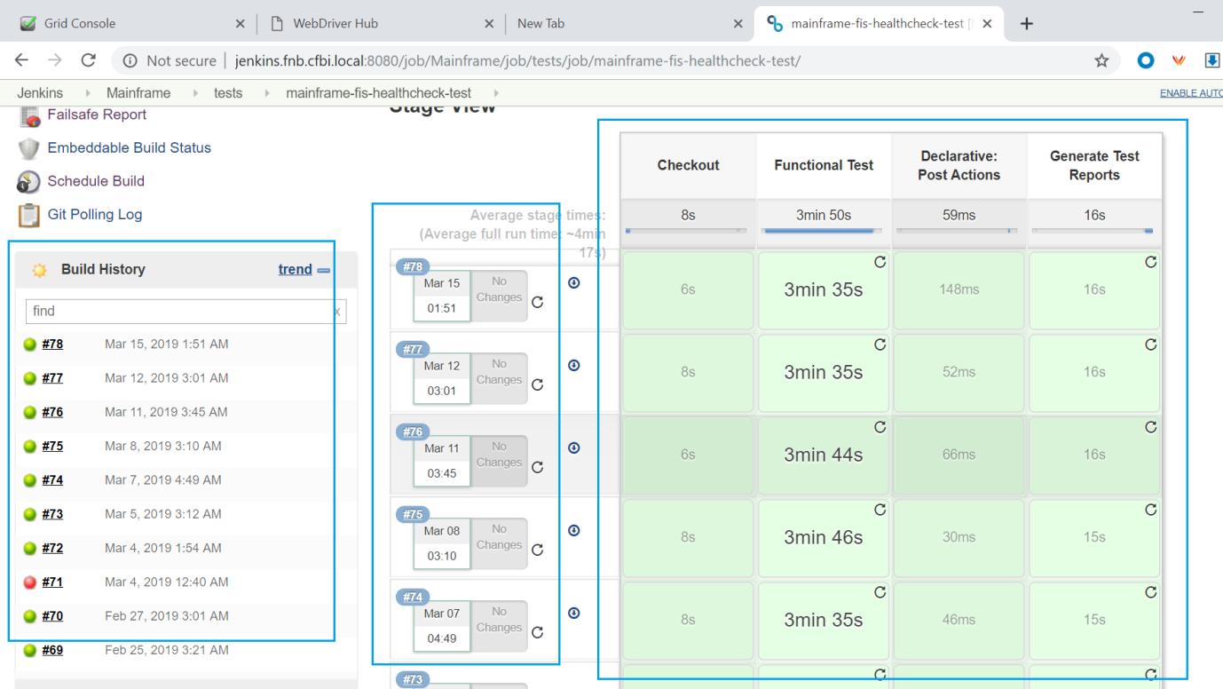

1. **PIPELINE – BUILD WITH PARAMETERS** - containing branch, browser, profile, failed email and success email.

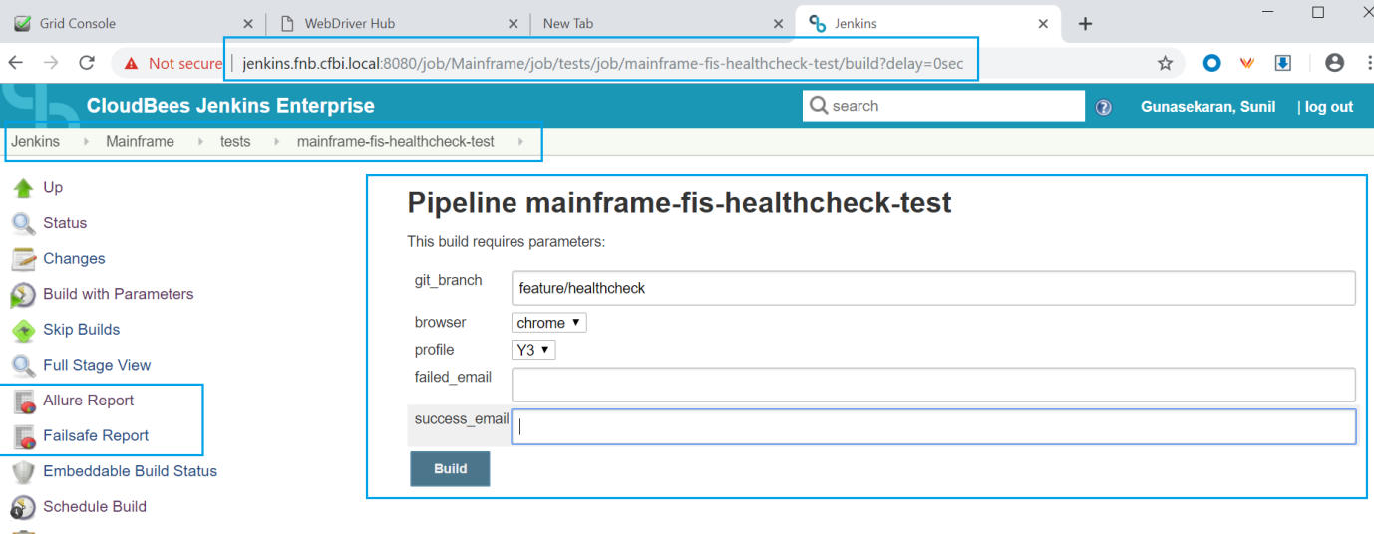

1. **IN BUILT ALLURE REPORT PLUGIN**

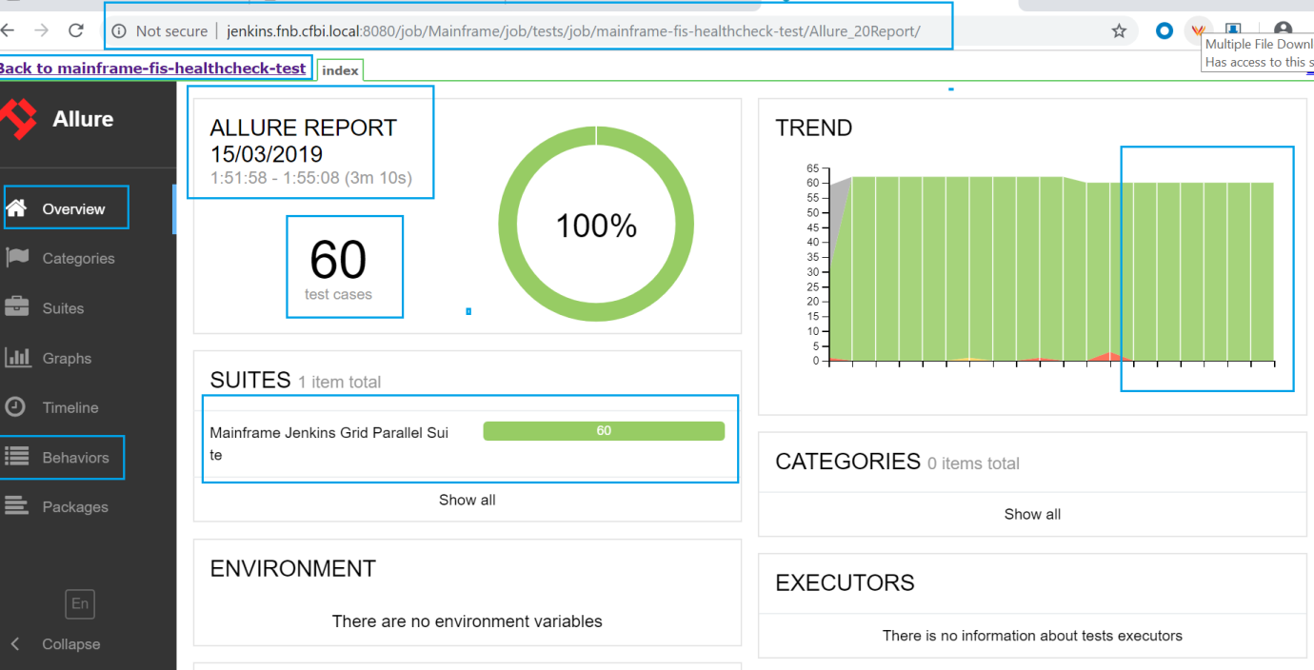

1. **Screenshots created in ‘Build Artefacts’ for the particular Jenkins job**

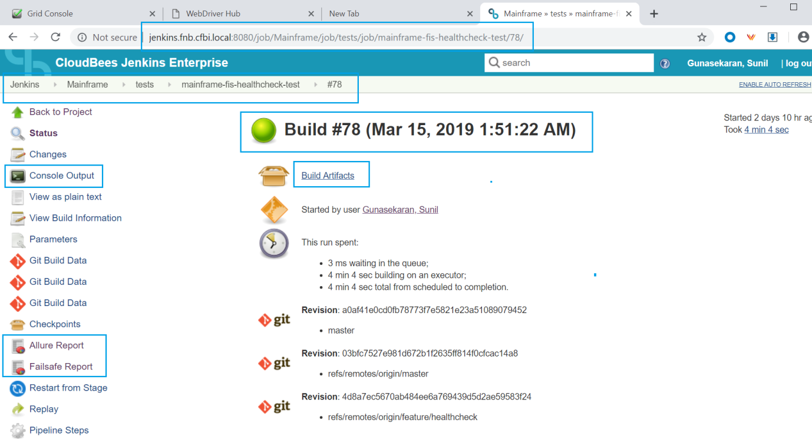

1. **After Batch text files updated in ‘Build Artefacts’**

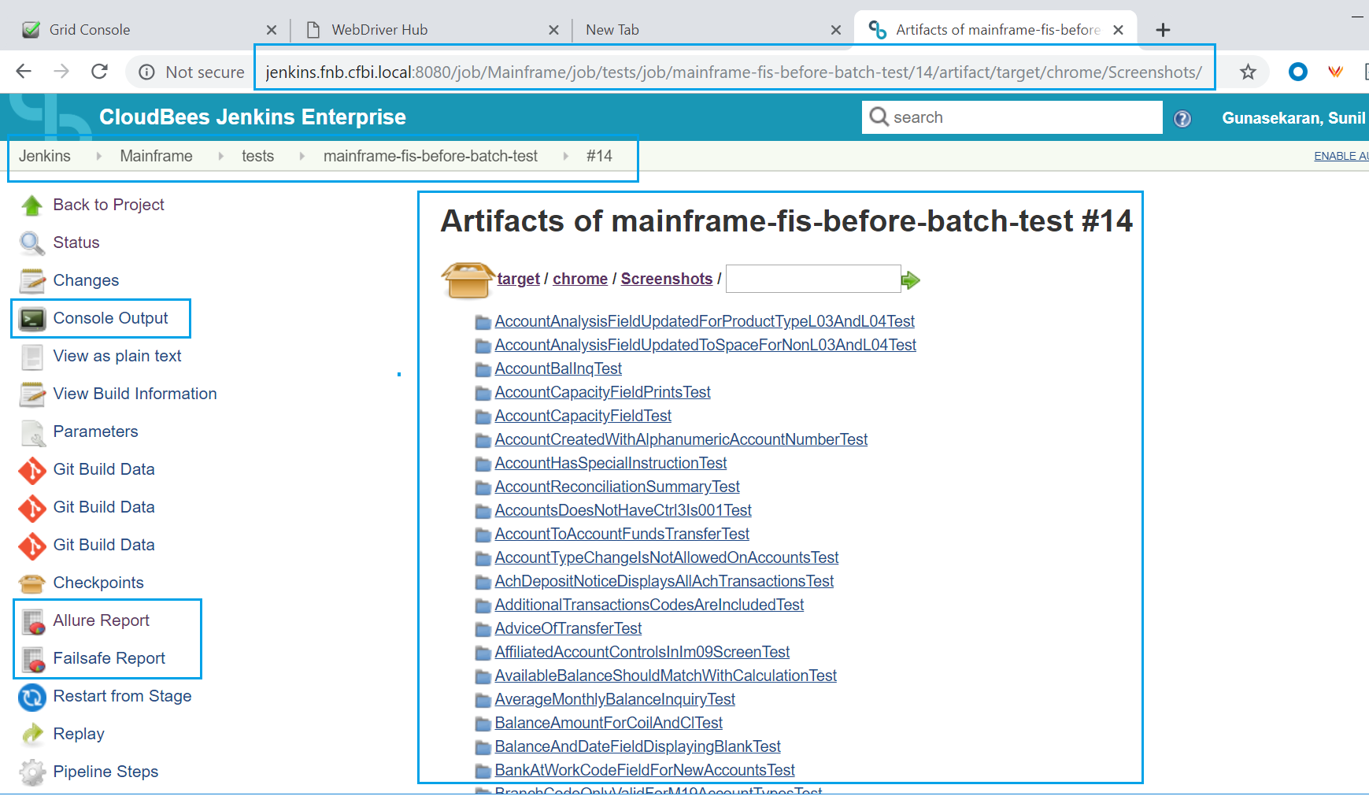

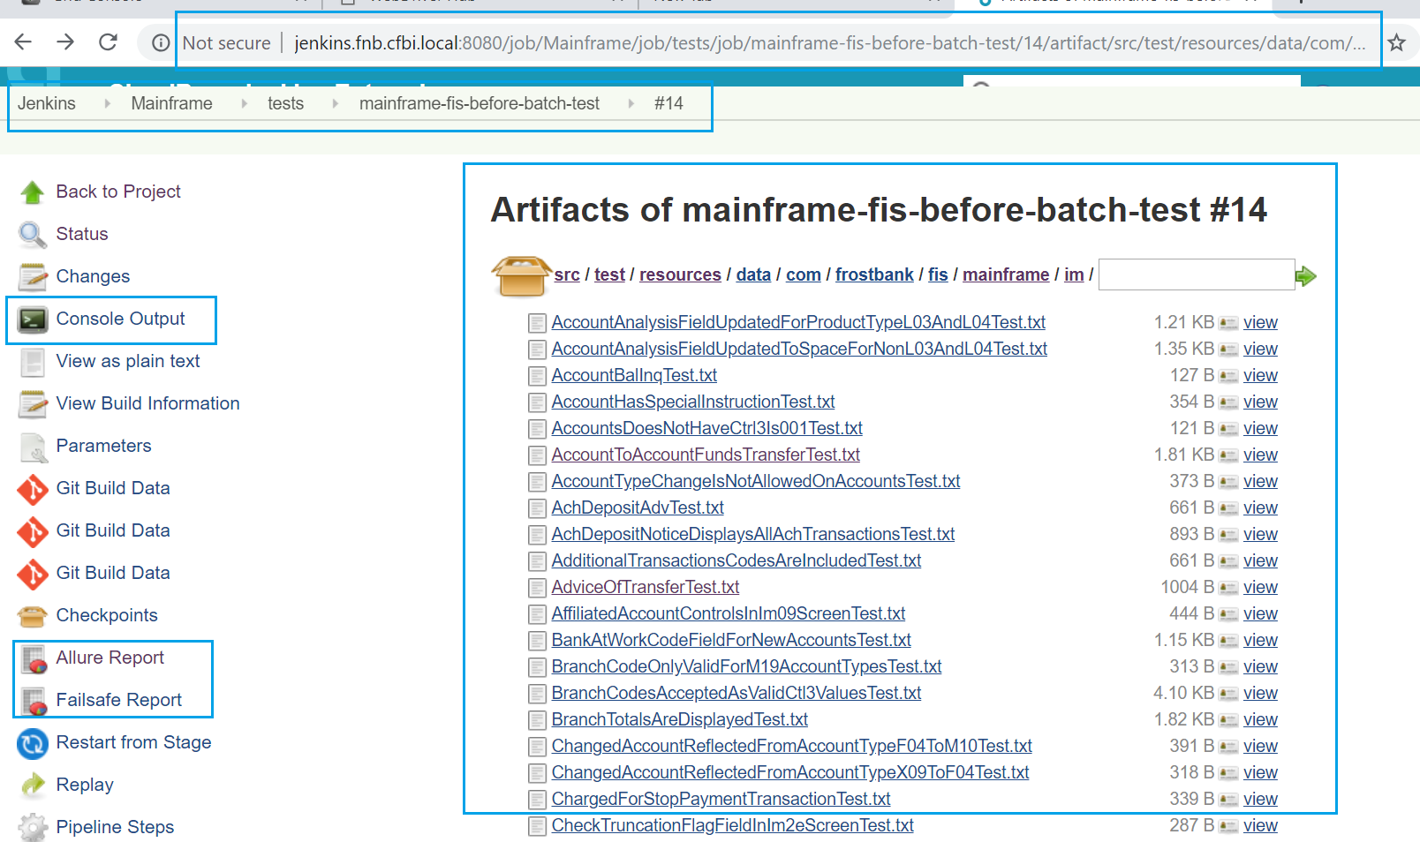

1. **IN BUILT FAILSAFE PLUGIN**

